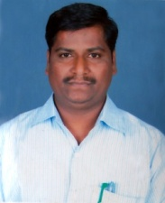
Dr.Kumarswamy R. Hiremath
Staff Profile
Faculty Name | Dr.Kumarswamy R. Hiremath
Designation | Principal
Academic Qualification | M.A
Professional Qualification | M.Ed, M.Phil, Ph.D, PGDHE
Date of Birth | 01/06/1977
Date of Appointment | 01/01/2022
Nature of Appointment | Permanent/Regular
Whether Approved by the Affiliating University/Body | Yes
Remuneration | Consolidated
Pay Scale | Consolidated
Consolidated Amount | Consolidated
Total Emoluments | Consolidated
Retirement Benefits EPF etc | EPF
Email | kumar.rh@rediffmail.com
Aadhar No. | 8229 4027 0453

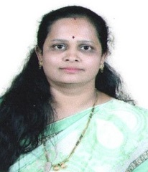

Smt.Jayashree S. Kengeri

Staff Profile
Faculty Name | Smt.Jayashree S. Kengeri
Designation | Lecturer
Academic Qualification | M.A
Professional Qualification | M.Ed
Date of Birth | 14-07-1979
Date of Appointment | 09/06/2014
Nature of Appointment | Permanent/Regular
Whether Approved by the Affiliating University/Body | Yes
Remuneration | Consolidated
Pay Scale | Consolidated
Consolidated Amount | Consolidated
Total Emoluments | Consolidated
Retirement Benefits EPF etc | EPF
Email | jayashreekengeri79@gmail.com
Aadhar No. | 6242 0218 6401
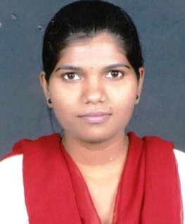

Smt.Nandini K. Kamble

Staff Profile
Faculty Name | Smt.Nandini K. Kamble
Designation | Lecturer
Academic Qualification | M.A
Professional Qualification | M.Ed
Date of Birth | 09-04-1986
Date of Appointment | 07/03/2016
Nature of Appointment | Permanent/Regular
Whether Approved by the Affiliating University/Body | Yes
Remuneration | Consolidated
Pay Scale | Consolidated
Consolidated Amount | Consolidated
Total Emoluments | Consolidated
Retirement Benefits EPF etc | EPF
Email | ssets.chandragiri@gmail.com
Aadhar No. | 5553 9218 6586

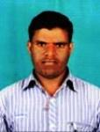

Mr.Mahantappa H. Talawar

Staff Profile
Faculty Name | Mr.Mahantappa H. Talawar
Designation | Lecturer
Academic Qualification | M.A
Professional Qualification | M.Ed
Date of Birth | 20-06-1989
Date of Appointment | 10/03/2016
Nature of Appointment | Permanent/Regular
Whether Approved by the Affiliating University/Body | Yes
Remuneration | Consolidated
Pay Scale | Consolidated
Consolidated Amount | Consolidated
Total Emoluments | Consolidated
Retirement Benefits EPF etc | EPF
Email | mahantappatalawar1234@gmail.com
Aadhar No. | 8032 5653 2993

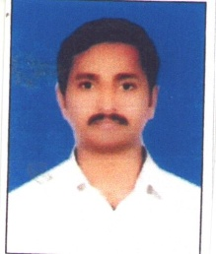
Mr.Shridhar K. Killiketar

Staff Profile
Faculty Name | Mr.Shridhar K. Killiketar
Designation | Lecturer
Academic Qualification | M.Sc
Professional Qualification | M.Ed
Date of Birth | 30-07-1985
Date of Appointment | 13/06/2017
Nature of Appointment | Permanent/Regular
Whether Approved by the Affiliating University/Body | Yes
Remuneration | Consolidated
Pay Scale | Consolidated
Consolidated Amount | Consolidated
Total Emoluments | Consolidated
Retirement Benefits EPF etc | EPF
Email | shreenvsk@gmail.com
Aadhar No. | 4282 5929 2765

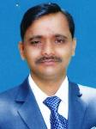
Mr.Fakirappa B. Meti

Staff Profile
Faculty Name | Mr.Fakirappa B. Meti
Designation | Lecturer
Academic Qualification | M.A
Professional Qualification | M.Ed
Date of Birth | 08-05-1978
Date of Appointment | 09/06/2014
Nature of Appointment | Permanent/Regular
Whether Approved by the Affiliating University/Body | Yes
Remuneration | Consolidated
Pay Scale | Consolidated
Consolidated Amount | Consolidated
Total Emoluments | Consolidated
Retirement Benefits EPF etc | EPF
Email | ssets.chandragiri@gmail.com
Aadhar No. | 6878 2691 8860

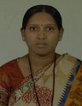
Smt.Maitra V. Koodagi

Staff Profile
Faculty Name | Smt.Maitra V. Koodagi
Designation | Lecturer
Academic Qualification | M.A
Professional Qualification | M.Ed
Date of Birth | 01-06-1981
Date of Appointment | 15/10/2019
Nature of Appointment | Permanent/Regular
Whether Approved by the Affiliating University/Body | Yes
Remuneration | Consolidated
Pay Scale | Consolidated
Consolidated Amount | Consolidated
Total Emoluments | Consolidated
Retirement Benefits EPF etc | -Nil-
Email | ssets.chandragiri@gmail.com
Aadhar No. | 8143 6258 8362

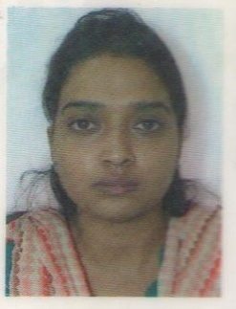
Smt.Shaista A. Maniyar

Staff Profile
Faculty Name | Smt.Shaista A. Maniyar
Designation | Lecturer
Academic Qualification | M.Sc
Professional Qualification | M.Ed
Date of Birth | 11-07-1986
Date of Appointment | 15/10/2019
Nature of Appointment | Permanent/Regular
Whether Approved by the Affiliating University/Body | Yes
Remuneration | Consolidated
Pay Scale | Consolidated
Consolidated Amount | Consolidated
Total Emoluments | Consolidated
Retirement Benefits EPF etc | -Nil-
Email | ssets.chandragiri@gmail.com
Aadhar No. | 8073 5770 7612

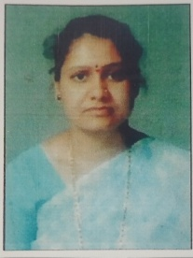
Smt.Girijadevi V. Sunkad

Staff Profile
Faculty Name | Smt.Girijadevi V. Sunkad
Designation | Lecturer
Academic Qualification | M.A
Professional Qualification | M.Ed, KSLET, (Ph.D)
Date of Birth | 17-10-1982
Date of Appointment | 01/08/2021
Nature of Appointment | Permanent/Regular
Whether Approved by the Affiliating University/Body | Yes
Remuneration | Consolidated
Pay Scale | Consolidated
Consolidated Amount | Consolidated
Total Emoluments | Consolidated
Retirement Benefits EPF etc | -Nil-
Email | ssets.chandragiri@gmail.com
Aadhar No. | 8743 5958 1467

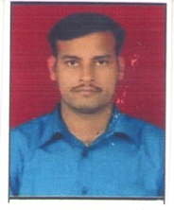
Mr.Shivanand S. Chavan

Staff Profile
Faculty Name | Mr.Shivanand S. Chavan
Designation | Lecturer
Academic Qualification | M.A
Professional Qualification | M.Ed
Date of Birth | 22-07-1979
Date of Appointment | 15/10/2019
Nature of Appointment | Permanent/Regular
Whether Approved by the Affiliating University/Body | Yes
Remuneration | Consolidated
Pay Scale | Consolidated
Consolidated Amount | Consolidated
Total Emoluments | Consolidated
Retirement Benefits EPF etc | -Nil-
Email | ssets.chandragiri@gmail.com
Aadhar No. | 7289 8415 1447

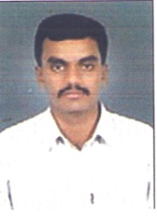
Mr.Shidramagouda S. Rayanaikar

Staff Profile
Faculty Name | Mr.Shidramagouda S. Rayanaikar
Designation | Lecturer
Academic Qualification | M.Sc
Professional Qualification | M.Ed
Date of Birth | 19-05-1984
Date of Appointment | 15/10/2019
Nature of Appointment | Permanent/Regular
Whether Approved by the Affiliating University/Body | Yes
Remuneration | Consolidated
Pay Scale | Consolidated
Consolidated Amount | Consolidated
Total Emoluments | Consolidated
Retirement Benefits EPF etc | -Nil-
Email | ssets.chandragiri@gmail.com
Aadhar No. | 5327 7066 8396

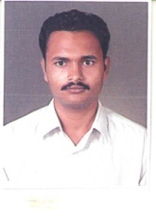
Dr.Shivakumar G. Manaturagimath

Staff Profile
Faculty Name | Dr.Shivakumar G. Manaturagimath
Designation | Lecturer
Academic Qualification | M.Sc
Professional Qualification | M.Ed, KSLET, Ph.D
Date of Birth | 01/05/1983
Date of Appointment | 15/10/2019
Nature of Appointment | Permanent/Regular
Whether Approved by the Affiliating University/Body | Yes
Remuneration | Consolidated
Pay Scale | Consolidated
Consolidated Amount | Consolidated
Total Emoluments | Consolidated
Retirement Benefits EPF etc | EPF
Email | smath260@gmail.com
Aadhar No. | 9592 0186 1652

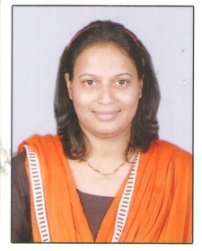
Smt.Shreeja R. James

Staff Profile
Faculty Name | Smt.Shreeja R. James
Designation | Lecturer
Academic Qualification | M.Sc
Professional Qualification | M.Ed
Date of Birth | 07-11-1987
Date of Appointment | 01/08/2021
Nature of Appointment | Permanent/Regular
Whether Approved by the Affiliating University/Body | Yes
Remuneration | Consolidated
Pay Scale | Consolidated
Consolidated Amount | Consolidated
Total Emoluments | Consolidated
Retirement Benefits EPF etc | -Nil-
Email | ssets.chandragiri@gmail.com
Aadhar No. | 3822 3525 6725

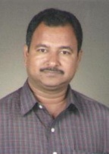
Mr.Vijayshankar S. Arlimatti

Staff Profile
Faculty Name | Mr.Vijayshankar S. Arlimatti
Designation | Physical Director
Academic Qualification | B.Sc
Professional Qualification | B.P.Ed and M.P.Ed
Date of Birth | 18-08-1964
Date of Appointment | 10/06/2014
Nature of Appointment | Permanent/Regular
Whether Approved by the Affiliating University/Body | Yes
Remuneration | Consolidated
Pay Scale | Consolidated
Consolidated Amount | Consolidated
Total Emoluments | Consolidated
Retirement Benefits EPF etc | -Nil-
Email | ssets.chandragiri@gmail.com
Aadhar No. | 3572 2437 9509

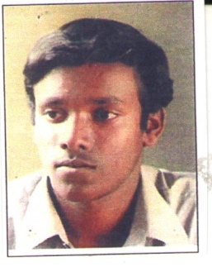
Mr.Vinayak M. Patagar

Staff Profile
Faculty Name | Mr.Vinayak M. Patagar
Designation | Art & Drawing Teacher
Academic Qualification | BFA
Professional Qualification | MFA
Date of Birth | 23-02-1990
Date of Appointment | 01/06/2016
Nature of Appointment | Permanent/Regular
Whether Approved by the Affiliating University/Body | Yes
Remuneration | Consolidated
Pay Scale | Consolidated
Consolidated Amount | Consolidated
Total Emoluments | Consolidated
Retirement Benefits EPF etc | -Nil-
Email | ssets.chandragiri@gmail.com
Aadhar No. | 9284 8923 9679

Dr.Sunita R. Siriyannavar

Staff Profile
Faculty Name | Dr.Sunita R. Siriyannavar
Designation | Music
Academic Qualification | B.Music
Professional Qualification | M.Music, Ph.D
Date of Birth | 16-03-1977
Date of Appointment | 01/06/2016
Nature of Appointment | Permanent/Regular
Whether Approved by the Affiliating University/Body | Yes
Remuneration | Consolidated
Pay Scale | Consolidated
Consolidated Amount | Consolidated
Total Emoluments | Consolidated
Retirement Benefits EPF etc | -Nil-
Email | ssets.chandragiri@gmail.com
Aadhar No. | 6080 5105 2173

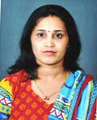
Smt.Manjula G. Chilakwad

Staff Profile
Faculty Name | Smt.Manjula G. Chilakwad
Designation | Librarian
Academic Qualification | M.A
Professional Qualification | B.Lib.I.Sci, M.Lib.I.Sci
Date of Birth | 12-02-1978
Date of Appointment | 18/01/2016
Nature of Appointment | Permanent/Regular
Whether Approved by the Affiliating University/Body | Yes
Remuneration | Consolidated
Pay Scale | Consolidated
Consolidated Amount | Consolidated
Total Emoluments | Consolidated
Retirement Benefits EPF etc | EPF
Email | ssets.chandragiri@gmail.com
Aadhar No. | 3485 2144 6433

